Flood Fest
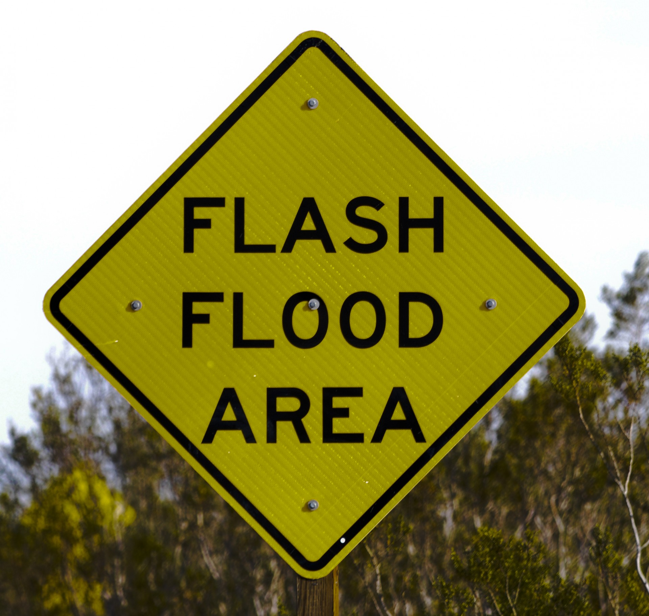  Hosted by Poland Vol. Fire Co. & Auxiliary, Newport Fire Co. and Middleville Fire Dept. |  | A Benefit for the Flood Victims of The Kuyahoora Valley. All proceeds will be donated to The Kuyahoora Valley Foundation.  Tickets Pre-Sale and at the Door.  $15 person $25 Couple $30 Family  Music by The Swamp Drivers & More
December 8, 2019 1:00pm-7:00pm
Poland FireHouse
216 State RT 8 Cold Brook NY 13324

FOOD, DRINKS, BASKET RAFFLE, 50/50

Food Donations Contact 315-725-7421
Basket Raffle Donations Contact 315-845-8995

